Reading

**Find the Main Idea**

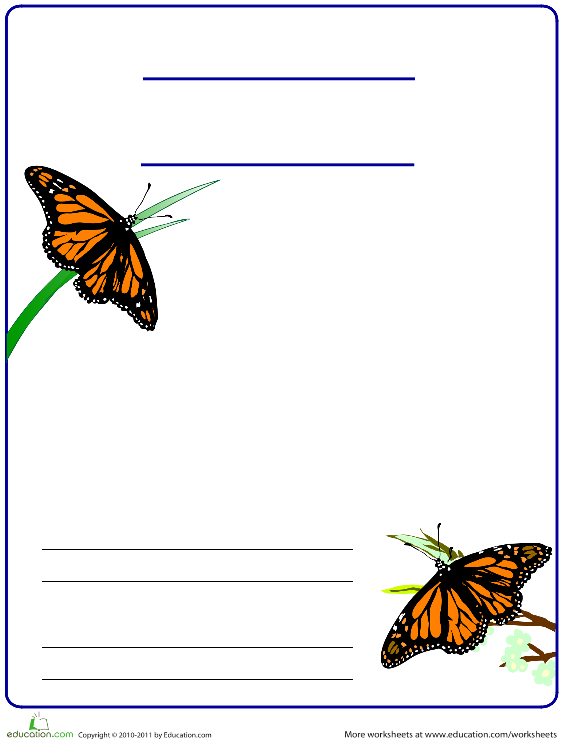

**Find the main idea in the paragraph below. Write the main idea in your own words in the space provided. Then, write a concluding sentence for this paragraph.**

Viceroy

You know that butterflies are insects that glide through the air on colorful wings. Did you know they are also masters of disguise? For example, the Viceroy butterfly has evolved to look almost exactly like the monarch, a poisonous butterfly that predators know to avoid. Though the

Viceroy itself is not poisonous, birds and other predators steer clear, mistaking it for the Monarch. The Buckeye sports “eyespots”, target-shaped spots resembling eyes, on the tips of its wings. Predators will aim for an eyespot, believing it to be the head of the Buckeye, but will instead end up with just a wing tip, allowing the Buckeye to escape.

**Main idea:**

The viceroy butterfly.

The viceroy butterfly.

**Concluding sentence:**

Next time you see a butterfly try to see if it is a viceroy or monarch.

Monarch